**“LIBRARY MANAGEMENT SYSTEM”**

**What is Library Management System?**

As the name suggest the Library Management System is a software which handles the entire data of library. It makes the work of librarian very easy instead of writing data in a notebook. In past the librarians were using notebooks to write the data of books along with students name who borrowed that book. So it was very difficult to keep track on each and every book.

If librarian want’s to search for a particular book then that task was very time consuming. So to make this task easy the programming languages were developed and C++ language is one of them.

**Features of Library Management System Project in C++**

* We have created separate logins for students and the librarian, in which the librarian is password protected.
* In this project, the librarian can add, update, delete and create books and can also assign the books to the students.
* The students can also view the list of the books available in the entire library database.
* The entire rights are given to the librarian to adding books, issuing books, and modify the book.
* This project uses file handling to store the data of books in a project.
* A Librarian can also be able to change the password.
* Reissuing and returning the books are the main features of this project.
* The student can also be able to see which student has already borrowed the book.

**Modules of Library Management System**

* Add Book.
* Modify Book.
* Delete Book.
* Search Book.
* Issue Book.
* Return Book.

**CODE:**

#include <iostream>

#include <string>

#include <fstream>

using namespace std;

int main(){

//help option

cout << "Welcome to Library Management System!\n";

cout << "This system allows you to manage books in a library.\n";

cout << "You can add, view, search, delete and update books.\n";

cout << "You can also lend books and keep track of the return date.\n";

cout << "Penalty will be charged if the book is not returned on time.\n";

cout << "You can choose from Admin or User options from the main menu.\n";

cout << "If you choose Admin, you will be asked for your ID and password.\n";

cout << "You can exit or go back in all menus by choosing the appropriate option.\n";

cout << "\n\n";

//main menu

cout << "Main Menu\n";

cout << "1. Admin\n";

cout << "2. User\n";

cout << "3. Help\n";

cout << "4. Exit\n\n";

cout << "Please choose an option: ";

int option;

cin >> option;

//admin menu

if(option == 1){

string id, password;

cout << "\nPlease enter your ID: ";

cin >> id;

cout << "\nPlease enter your password: ";

cin >> password;

if(id == "admin" && password == "admin123"){

cout << "\nAdmin Menu\n";

cout << "1. Add Book\n";

cout << "2. View Book\n";

cout << "3. Search Book\n";

cout << "4. Delete Book\n";

cout << "5. Update Book\n";

cout << "6. Exit\n\n";

cout << "Please choose an option: ";

int adminOption;

cin >> adminOption;

//add book

if(adminOption == 1){

string bookName, authorName;

int bookID;

cout << "\nPlease enter the book name: ";

cin >> bookName;

cout << "\nPlease enter the author name: ";

cin >> authorName;

cout << "\nPlease enter the book ID: ";

cin >> bookID;

ofstream outfile;

outfile.open("BookData.txt", ios::app);

outfile << bookID << "," << bookName << "," << authorName << endl;

outfile.close();

cout << "\nBook has been added successfully!\n\n";

main();

}

//view book

else if(adminOption == 2){

ifstream infile;

infile.open("BookData.txt");

string data;

cout << "\nBook Name" << "\t" << "Author Name" << "\t" << "Book ID" << endl;

while(getline(infile, data)){

int i;

string bookName, authorName;

int bookID;

for(i = 0; data[i] != ','; i++){

bookID = bookID * 10 + (data[i] - '0');

}

for(i = i + 1; data[i] != ','; i++){

bookName += data[i];

}

for(i = i + 1; data[i] != '\0'; i++){

authorName += data[i];

}

cout << bookName << "\t" << authorName << "\t" << bookID << endl;

}

infile.close();

cout << "\n";

main();

}

//search book

else if(adminOption == 3){

ifstream infile;

infile.open("BookData.txt");

string data;

int searchID;

cout << "\nPlease enter the Book ID to search: ";

cin >> searchID;

cout << "\nBook Name" << "\t" << "Author Name" << "\t" << "Book ID" << endl;

while(getline(infile, data)){

int i;

string bookName, authorName;

int bookID;

for(i = 0; data[i] != ','; i++){

bookID = bookID * 10 + (data[i] - '0');

}

for(i = i + 1; data[i] != ','; i++){

bookName += data[i];

}

for(i = i + 1; data[i] != '\0'; i++){

authorName += data[i];

}

if(bookID == searchID){

cout << bookName << "\t" << authorName << "\t" << bookID << endl;

}

}

infile.close();

cout << "\n";

main();

}

//delete book

else if(adminOption == 4){

ifstream infile;

infile.open("BookData.txt");

string data;

int deleteID;

cout << "\nPlease enter the Book ID to delete: ";

cin >> deleteID;

ofstream tempFile;

tempFile.open("temp.txt");

while(getline(infile, data)){

int i;

string bookName, authorName;

int bookID;

for(i = 0; data[i] != ','; i++){

bookID = bookID * 10 + (data[i] - '0');

}

for(i = i + 1; data[i] != ','; i++){

bookName += data[i];

}

for(i = i + 1; data[i] != '\0'; i++){

authorName += data[i];

}

if(bookID != deleteID){

tempFile << bookID << "," << bookName << "," << authorName << endl;

}

}

infile.close();

tempFile.close();

remove("BookData.txt");

rename("temp.txt", "BookData.txt");

cout << "\nBook has been deleted successfully!\n\n";

main();

}

//update book

else if(adminOption == 5){

ifstream infile;

infile.open("BookData.txt");

string data;

int updateID;

cout << "\nPlease enter the Book ID to update: ";

cin >> updateID;

ofstream tempFile;

tempFile.open("temp.txt");

while(getline(infile, data)){

int i;

string bookName, authorName;

int bookID;

for(i = 0; data[i] != ','; i++){

bookID = bookID * 10 + (data[i] - '0');

}

for(i = i + 1; data[i] != ','; i++){

bookName += data[i];

}

for(i = i + 1; data[i] != '\0'; i++){

authorName += data[i];

}

if(bookID == updateID){

cout << "\nPlease enter the book name: ";

cin >> bookName;

cout << "\nPlease enter the author name: ";

cin >> authorName;

tempFile << bookID << "," << bookName << "," << authorName << endl;

}

else{

tempFile << bookID << "," << bookName << "," << authorName << endl;

}

}

infile.close();

tempFile.close();

remove("BookData.txt");

rename("temp.txt", "BookData.txt");

cout << "\nBook has been updated successfully!\n\n";

main();

}

//exit

else if(adminOption == 6){

return 0;

}

//invalid option

else{

cout << "\nInvalid option!\n\n";

main();

}

}

//invalid id or password

else{

cout << "\nInvalid ID or password!\n\n";

main();

}

}

//user menu

else if(option == 2){

cout << "\nUser Menu\n";

cout << "1. Lend Book\n";

cout << "2. Return Book\n";

cout << "3. View Book\n";

cout << "4. Search Book\n";

cout << "5. Exit\n\n";

cout << "Please choose an option: ";

int userOption;

cin >> userOption;

//lend book

if(userOption == 1){

ifstream infile;

infile.open("BookData.txt");

string data;

int lendID;

cout << "\nPlease enter the Book ID to lend: ";

cin >> lendID;

cout << "\nBook Name" << "\t" << "Author Name" << "\t" << "Book ID" << endl;

while(getline(infile, data)){

int i;

string bookName, authorName;

int bookID;

for(i = 0; data[i] != ','; i++){

bookID = bookID * 10 + (data[i] - '0');

}

for(i = i + 1; data[i] != ','; i++){

bookName += data[i];

}

for(i = i + 1; data[i] != '\0'; i++){

authorName += data[i];

}

if(bookID == lendID){

cout << bookName << "\t" << authorName << "\t" << bookID << endl;

ofstream outfile;

outfile.open("LendData.txt", ios::app);

outfile << bookID << "," << bookName << "," << authorName << endl;

outfile.close();

cout << "\nBook has been lent successfully!\n\n";

}

}

infile.close();

cout << "\n";

main();

}

//return book

else if(userOption == 2){

ifstream infile;

infile.open("LendData.txt");

string data;

int returnID;

cout << "\nPlease enter the Book ID to return: ";

cin >> returnID;

cout << "\nBook Name" << "\t" << "Author Name" << "\t" << "Book ID" << endl;

while(getline(infile, data)){

int i;

string bookName, authorName;

int bookID;

for(i = 0; data[i] != ','; i++){

bookID = bookID * 10 + (data[i] - '0');

}

for(i = i + 1; data[i] != ','; i++){

bookName += data[i];

}

for(i = i + 1; data[i] != '\0'; i++){

authorName += data[i];

}

if(bookID == returnID){

cout << bookName << "\t" << authorName << "\t" << bookID << endl;

ofstream outfile;

outfile.open("ReturnData.txt", ios::app);

outfile << bookID << "," << bookName << "," << authorName << endl;

outfile.close();

cout << "\nBook has been returned successfully!\n\n";

}

}

infile.close();

cout << "\n";

main();

}

//view book

else if(userOption == 3){

ifstream infile;

infile.open("BookData.txt");

string data;

cout << "\nBook Name" << "\t" << "Author Name" << "\t" << "Book ID" << endl;

while(getline(infile, data)){

int i;

string bookName, authorName;

int bookID;

for(i = 0; data[i] != ','; i++){

bookID = bookID * 10 + (data[i] - '0');

}

for(i = i + 1; data[i] != ','; i++){

bookName += data[i];

}

for(i = i + 1; data[i] != '\0'; i++){

authorName += data[i];

}

cout << bookName << "\t" << authorName << "\t" << bookID << endl;

}

infile.close();

cout << "\n";

main();

}

//search book

else if(userOption == 4){

ifstream infile;

infile.open("BookData.txt");

string data;

int searchID;

cout << "\nPlease enter the Book ID to search: ";

cin >> searchID;

cout << "\nBook Name" << "\t" << "Author Name" << "\t" << "Book ID" << endl;

while(getline(infile, data)){

int i;

string bookName, authorName;

int bookID;

for(i = 0; data[i] != ','; i++){

bookID = bookID * 10 + (data[i] - '0');

}

for(i = i + 1; data[i] != ','; i++){

bookName += data[i];

}

for(i = i + 1; data[i] != '\0'; i++){

authorName += data[i];

}

if(bookID == searchID){

cout << bookName << "\t" << authorName << "\t" << bookID << endl;

}

}

infile.close();

cout << "\n";

main();

}

//exit

else if(userOption == 5){

return 0;

}

//invalid option

else{

cout << "\nInvalid option!\n\n";

main();

}

}

//help option

else if(option == 3){

cout << "Welcome to Library Management System!\n";

cout << "This system allows you to manage books in a library.\n";

cout << "You can add, view, search, delete and update books.\n";

cout << "You can also lend books and keep track of the return date.\n";

cout << "Penalty will be charged if the book is not returned on time.\n";

cout << "You can choose from Admin or User options from the main menu.\n";

cout << "If you choose Admin, you will be asked for your ID and password.\n";

cout << "You can exit or go back in all menus by choosing the appropriate option.\n";

cout << "\n\n";

main();

}

//exit

else if(option == 4){

return 0;

}

//invalid option

else{

cout << "\nInvalid option!\n\n";

main();

}

}

**CONSOLE OUTPUT:**

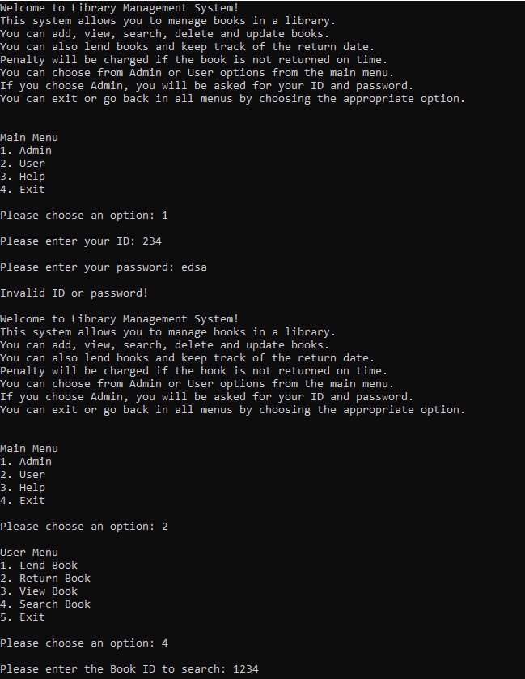

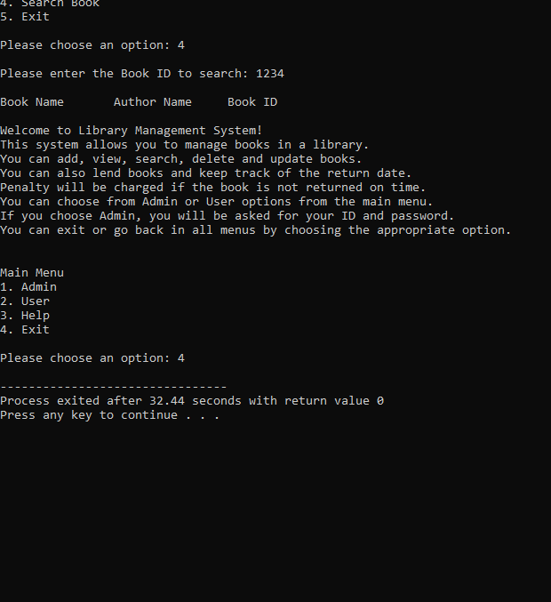

**WORKING OF THE PROJECT:**

**Main Screen:**

When you run the project from any compiler or directly clicking on the executable .exe file you’ll see the following screen shown in the picture.

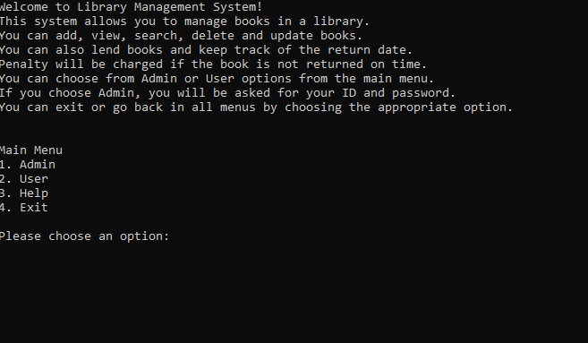

We have displayed the menu of Admin, User , help and close the application. If you’re an admin then your choice will be 1 and if you are a user then your choice will be 2, and if you require any help , you will opt for 3.

Now we’ll discuss each and every menu in details.

* 1. **ADMIN:**

When you go for option 1 as an admin, you require the following options:

Your id and your password is required which is saved as **admin** and **admin123** respectively.

Or else it will give invalid ID and password and may not proceed.

Furthermore , the options you avail are as under:

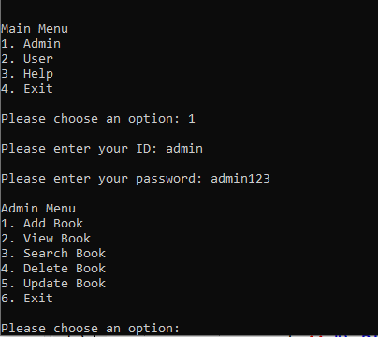

**ADD BOOK:**

Allows you to add any book in your library with the name author as well as the id for the book.

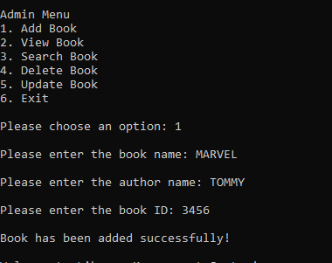

The rest options require you to know the IDs of the books available and may show you the list of them aswell.

* 1. **USER:**

As you choose option 2 in the menu, you get the following list:

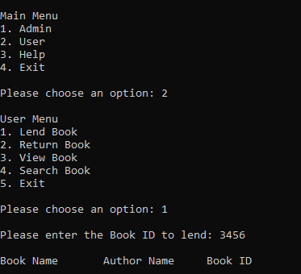

All these options are available for you while knowing the IDs of the books available in the library.

* 1. **HELP:**

The help option goes on for 3, which gives the following guideline:

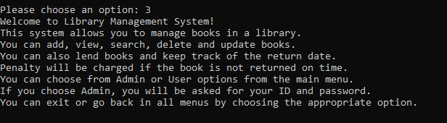

* 1. **EXIT:**

The exit status makes you finish the program or close your system.

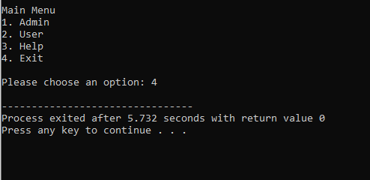

**FILE CREATED USING FSTREAM IN DEVC++**

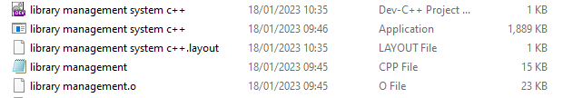

**CONCLUSION:**

The library management system is made in **DEV C++** to know for the options as admin, user to get the details of the books in a library for which the Book IDs are necessary to be remembered. We acknowledged to use **C++** language to make our program run easily. The console output required is also upto the point.